Assignment – 01
SQL PK&FK

Part A – Table Creation
- Create a table Department with the following fields:
  - dept_id (Primary Key)
  - dept_name
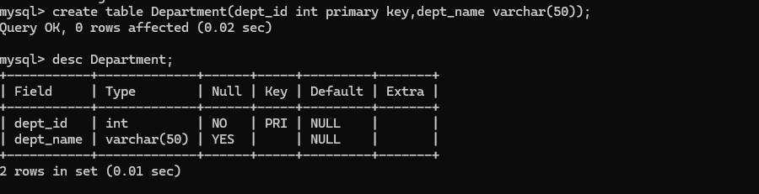
- Create a table Employee with the following fields:
  - emp_id (Primary Key)
  - emp_name
  - salary
  - dept_id (Foreign Key referencing Department)
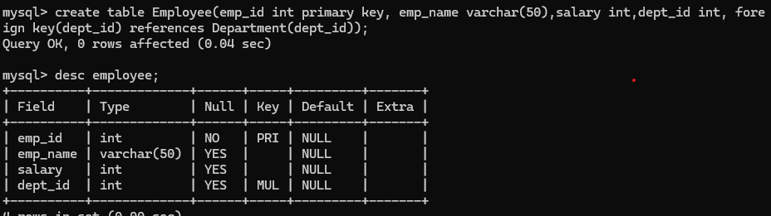

Part B – Data Insertion
- Insert at least 3 departments and 5 employees into the respective tables.
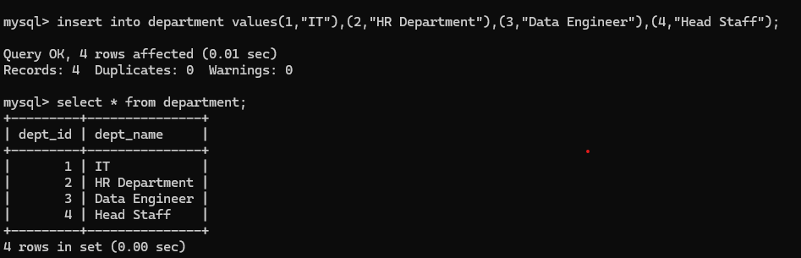
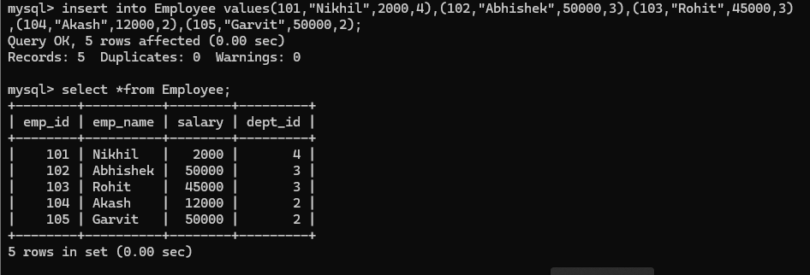

Part C – Queries to Solve
- Display all employees with their department names.
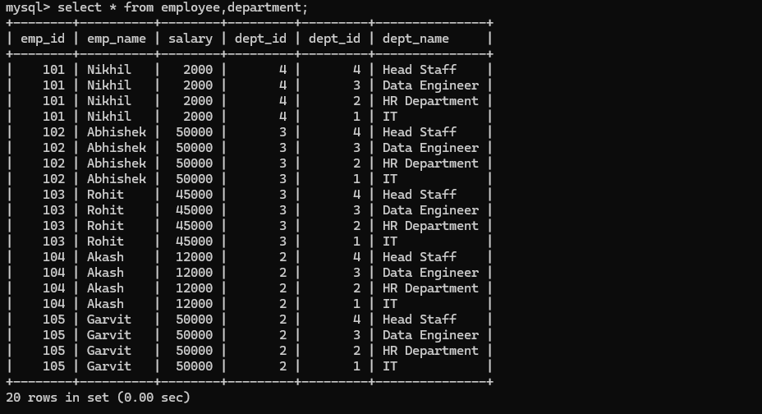
- Find employees who work in the IT department.

- List department names along with the number of employees in each department.
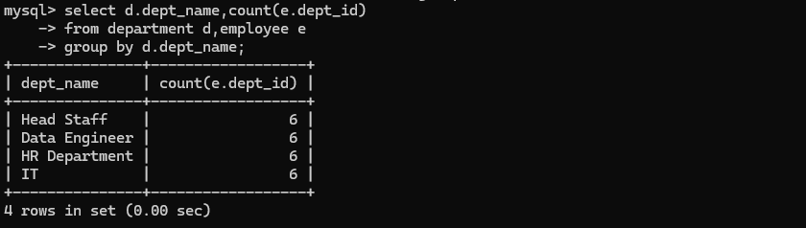
- Add a new employee 'Meena' in department 'Finance'.
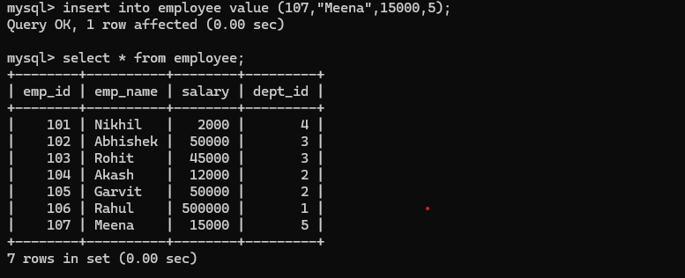
- Try inserting an employee with a non-existing department id (say dept_id = 10). What happens? why?
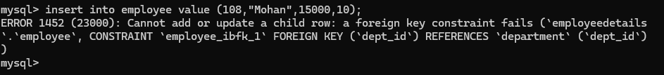
- Delete the Finance department. What happens to employees in that department?

Part D – Advanced Tasks
- Modify the Employee table so that if a department is deleted, all its employees are also deleted (ON DELETE CASCADE).

- Verify the above by deleting the Finance department again.
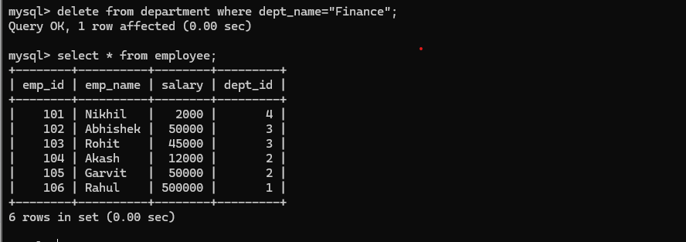
- Modify the Employee table so that if the department_id in Department is updated, it should also update automatically in the Employee table (ON UPDATE CASCADE).
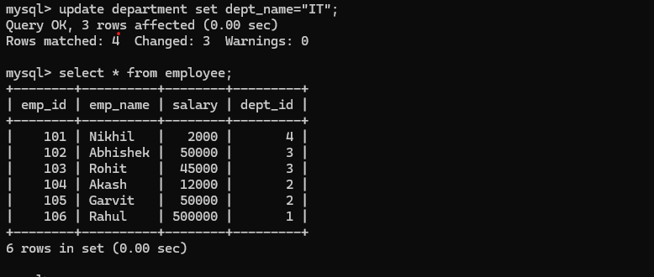
- Verify by updating the dept_id of the IT department to a new value. What happens to the employees in that department?
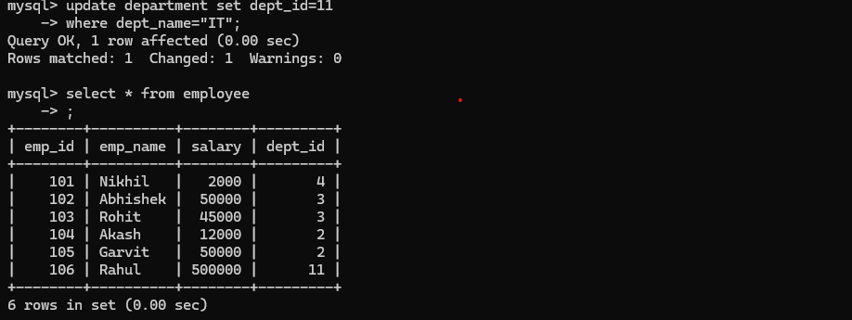
- Change the Foreign Key constraint so that if a department is deleted, employees should have their dept_id set to NULL (ON DELETE SET NULL).

- Test the above by deleting the HR department. What happens to the employees under HR?


